Streaming Ticket Assignment for Efficient support operations

Team ID:NM2025TMIDO3455

Team Size:4
Team Leader: Jenifer Shanu S
Team member: Jenisha M
Team member: Jerofiya C S
Team member: kalaivani M

Objective:
The objective of this project is to automate and streamline the ticket assignment process to improve efficiency in support operations. It aims to reduce manual effort, ensure faster response times, and enhance customer satisfaction.
Skills:
Python, Java, HTML, CSS, JavaScript, MySQL, Automation Tools, Problem-Solving, Analytical Thinking, Team Collaboration, Communication Skills.

TASK INTIATION
Milestone 1:User
Activity 1 :Create Users open service now.

.Click on All >> search for users

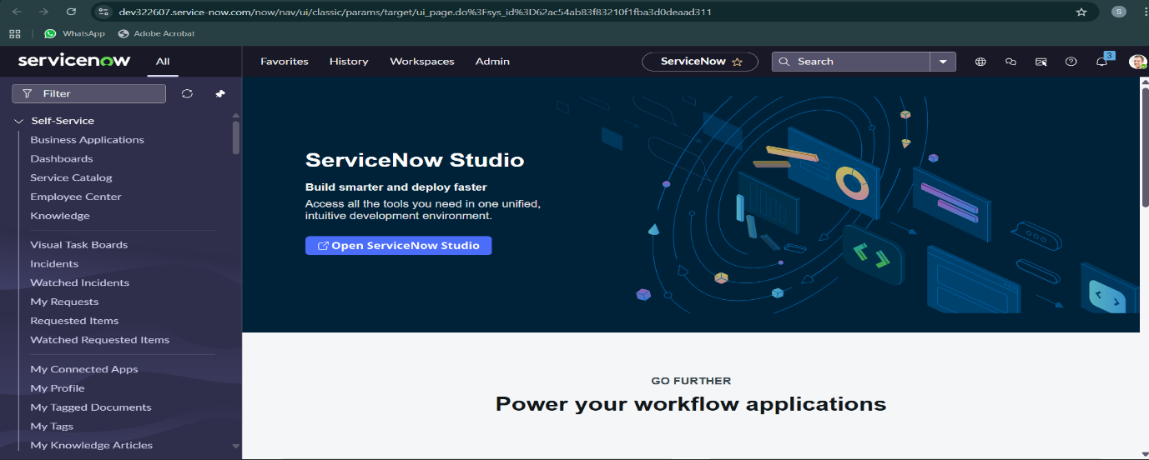

.Select Users under system security
.Click on new
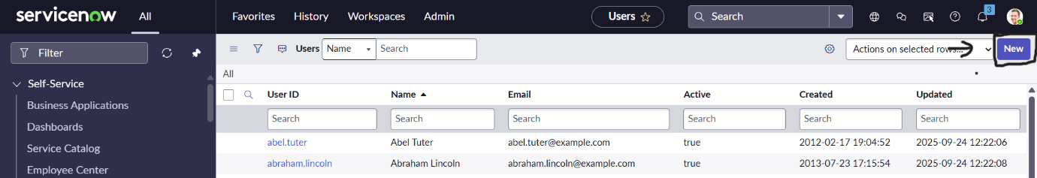

Fill the following details to create a new user
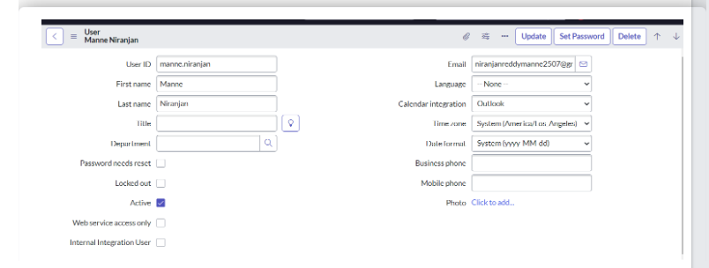

. Click on submit
. Create one more user:
.Create another user with the following details

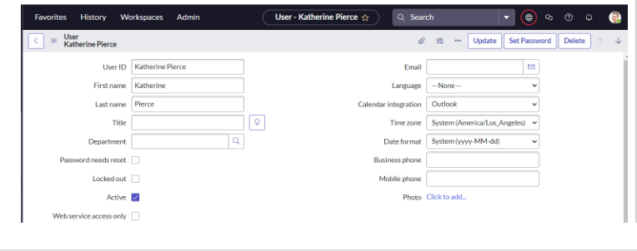
.Click on submit

2 .Creating Groups
Click on All >> search for groups
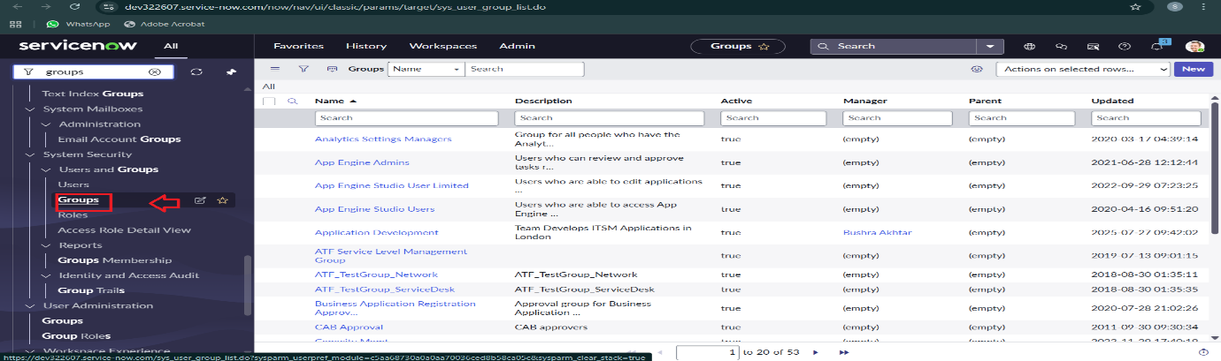
.Click on new

.Fill the following details to create a new group
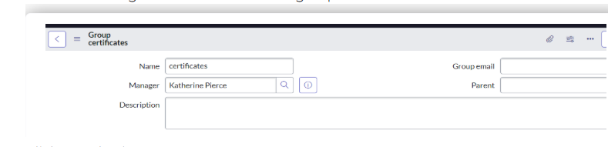
.Click on submit
Create one more group:
.Create another group with the following details
.Click on submit

Creates Roles:
.Click on All >> search for roles
. Select roles under system security
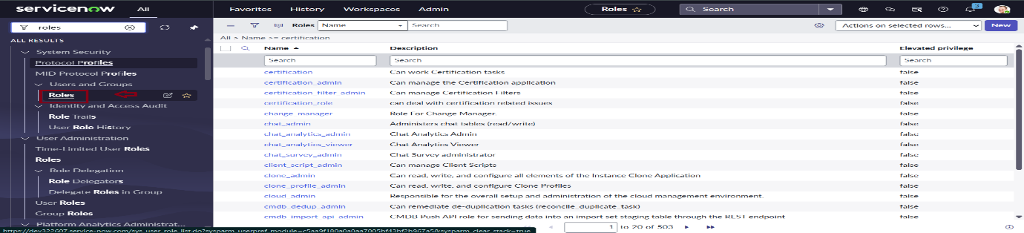

.Click on new

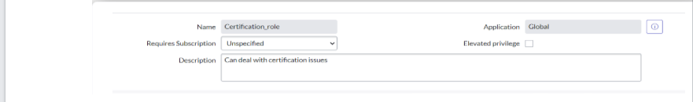
. Click on submit
.Create one more role
.Fill the following details to create a new role
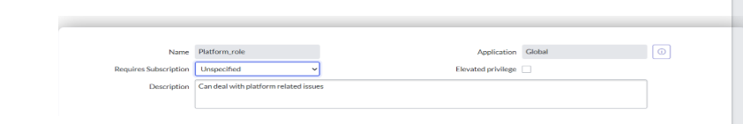

.Click on submit

Create Table:
Click on All >> search for tables

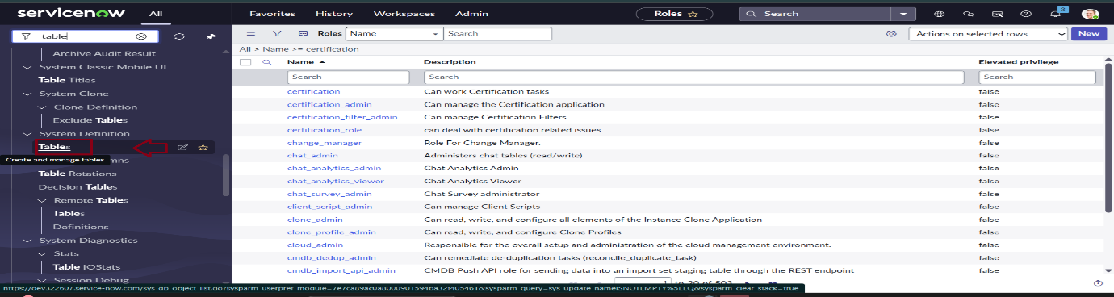
.Click on new
.Fill the following details to create a new table
.Label : Operations related

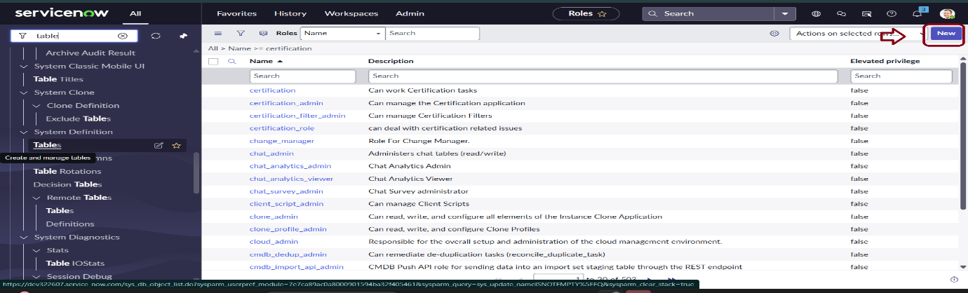
.Under table columns give the columns

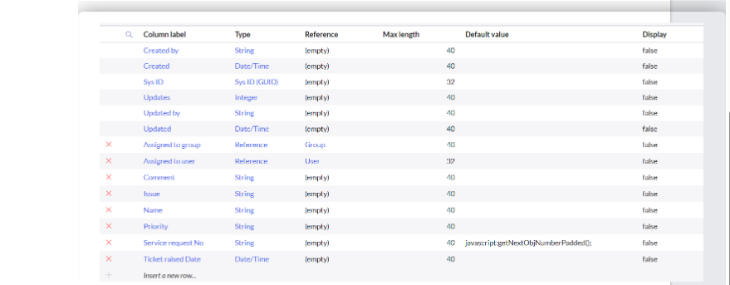
.Click on submit
. Create choices for the issue filed by using form design
Choices are
  - unable to login to platform
  - 404 error
  - regarding certificates
  - regarding user expired

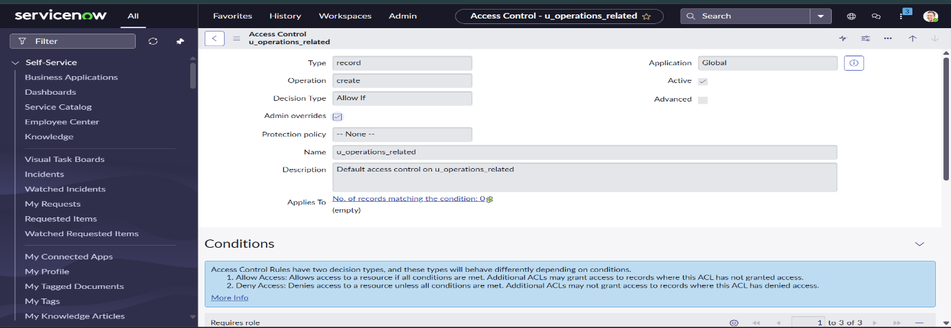

Assign Roles &Users To Groups:
1.Assign Roles & users to Certificate group
.Click on All >> search for tables

.Select Katherine Pierce and save
.Click on roles
.Select Certification_role and save
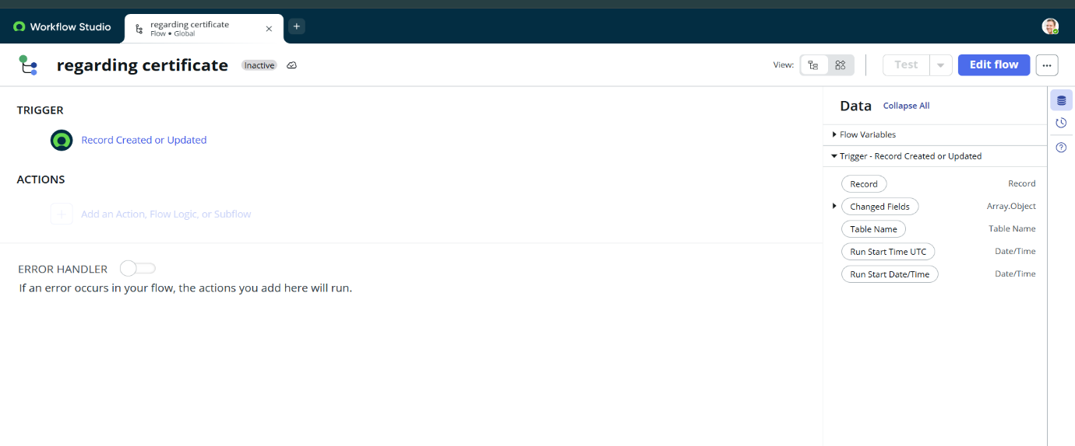

Assign Roles &Users to platform Group:
.Click on All >> search for tables

.Select Manne Niranjan and save

.Click on roles
.Select Platform_role and save

Assign Role To Table:
. Click on All >> search for tables

.Click on elevate role
.Click on security admin and click on update
.Under Requires role
. Double click on insert a new row

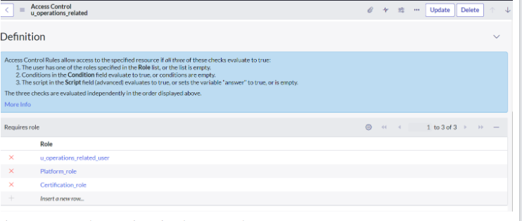

.Give platform role
.And add certificate role

Create Acl:
Click on All >> search for ACL

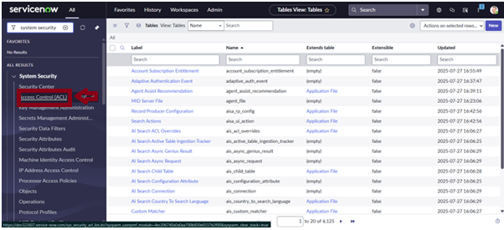

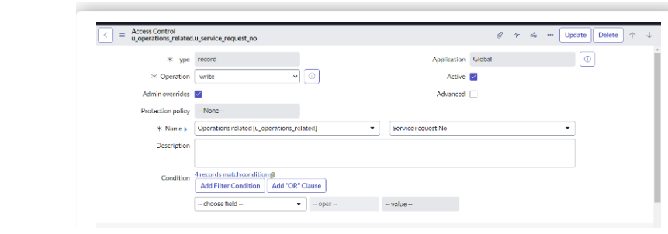

Give admin role
Click on submit
Similarly create 4 acl for the following fields

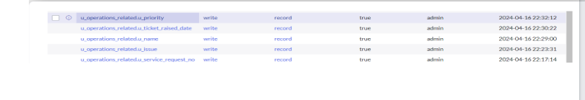

Flow:
.Create a flow to assign operation tickect group
Click on Flow Designer under Process Automation.

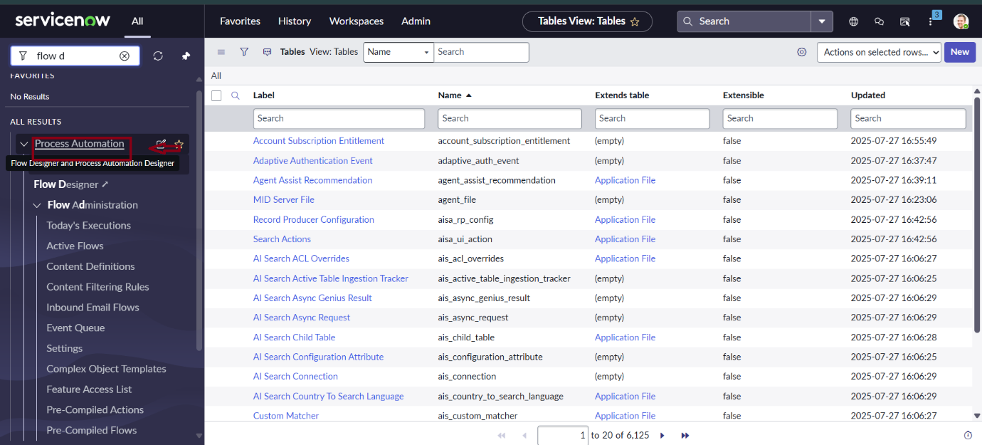

.Table will be auto assigned after that
.Give the field as “ Assigned to group ”
.Give value as “ Certificates ”
.Click on Done.
.Click on Save to save the Flow.
.Click on Activate.
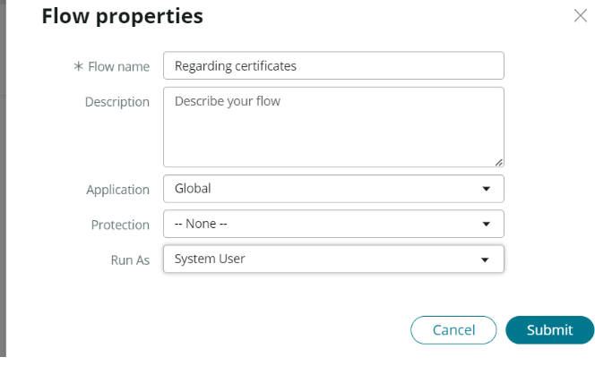

Create a flow to assign operation ticket to platform group:
.Click on All >> search for Flow Designer
.Click on Flow Designer under Process Automation.

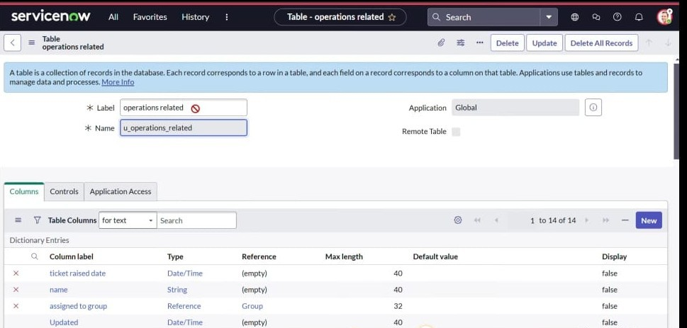

.Select the trigger in that Search for “create or .update a record” and select that.
.Give the table name as “ Operations related ”

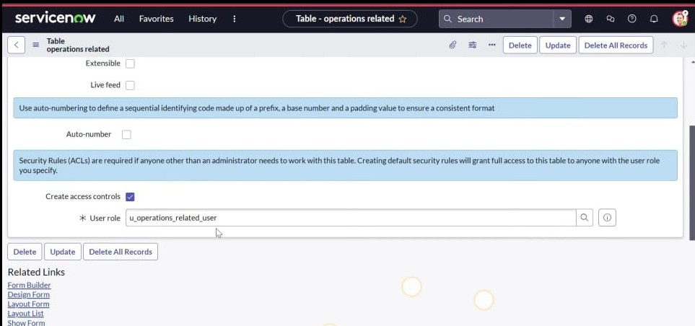

.Give the field as “ Assigned to group ”.
.Give value as “ Platform ”.
.Click on Done.
.Click on Save to save the Flow

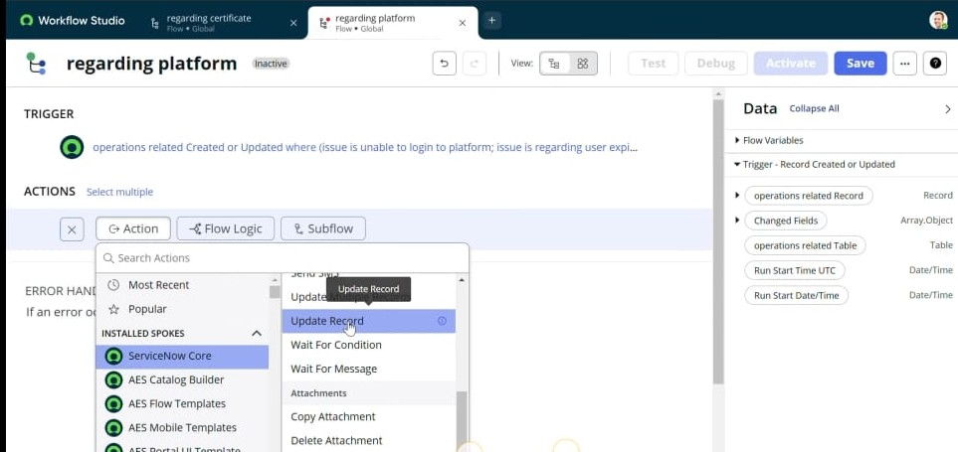
.Click on Activate.
Conclusion: The implementation of the automated ticket routing system at ABC Corporation has been a significant success. By leveraging the capabilities of ServiceNow, we have streamlined the process of assigning support tickets to the appropriate teams, addressing the challenges of manual routing, and ensuring timely resolution of issues.

